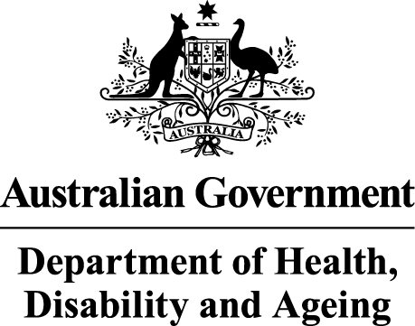
Australian Government
Department of Health, Disability and Ageing
National Shed Development Programme
Administered by the Australian Men’s Shed Association
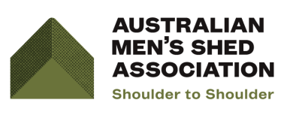

Round 31 - Preparing Your Application

The Guidelines
      - Please read the Guidelines thoroughly and ensure you understand eligibility, funding priority groups, the categories and funding limits.
      - Applications must be submitted by the closing time outlined. Please ensure you have a full understanding of each section of the application early and ask for assistance if there are areas of concern.
      - If the application form is being submitted electronically, the form must be submitted as one single PDF document (including quotes, images etc.) only, and not individual jpeg/word/PDF files, otherwise the application must be posted via conventional mail.
      - It is your responsibility to ensure that the application form is completed correctly, on time and signed, and that all the required information and documents are available.
      - If you have questions relating to the Application Form, or the programme, the AMSA can be contacted by email at amsa@mensshed.net, or by telephone on 1300 550 009.

The Application
      - Answer all relevant questions.
- Priority will be given to Men’s Sheds that provide services in areas of greatest need, in particular to individuals and/or communities experiencing levels of disadvantage (for example, high levels of unemployment; effects of natural disaster; high rates of chronic illness/disease, etc). Please describe the need and level of disadvantage in the region/district in which your Men’s Shed is located.
    - Your response to Part D: Question 1 provides important information for the Evaluation Panel to determine levels of disadvantage within your community.

      - Defibrillators and associated training will be prioritised where sheds can evidence not having a defibrillator, or having one that was purchased prior to January2020 (older than six years). Note that defibrillators need to be applied for using a separate application form, as they have different time restrictions to NSDP rounds. The application form can be found at https://mensshed.org/development-grants/.
      - Where the above elements do not apply, applications will be prioritised(unless ineligible) where sheds can evidence being in an area of social disadvantage and/or supporting members that are from the 12 priority population groups (see Section 7 of the NSDP Guidelines).
      - Partnerships and in-kind support/ contributions - provide information about existing and potential partnerships – this demonstrates the level of your engagement with the community, joint activities and the additional support that you have received.
      - Make sure you have completed the checklist and attached all necessary documents.
      - Make sure the application has been signed by a person with delegation of authority. For example, President, Treasurer, or Secretary.

Compulsory Attachments

Quotes
- Where possible, applicants must provide at least two quotes for each of the goods and/or services you are seeking funding for under your application.
- Pricings from online vendors will be considered acceptable as quotes, provided:
        - the vendor has a current Australian Business Number (ABN); and
        - appropriate detail on what is being provided by the vendor is included with the pricing.
- If you have trouble with obtaining two quotes or are uncertain as to whether your online pricings meet requirements, you MUST contact the AMSA to discuss your situation BEFORE submitting your application.
- AMSA can be contacted by email at amsa@mensshed.net, or by telephone on 1300 550 009.

Non-Member
- If an AMSA Non-Member, please provide evidence to allow your shed’s status to be confirmed, for example shed constitution, program of events, or other evidence of activities.

Relevant permissions
- Applications for grant funding to refurbish a building will require written permission by the owner of the premises.
- Local Government approvals/permits must be supplied if you are applying for renovations/improvements in Category Two- Shed Improvements.

- A Memorandum of Understanding between an auspicing body and your shed should be provided, where relevant.

Lodging the Application
- Applications including supporting documentation should be submitted electronically to amsa@mensshed.netby the due date as one single PDF document (including quotes, images etc) only and not individual jpeg/word/PDF files.
- If you are unable to provide your application electronically, or cannot provide it electronically as one single PDF document, an address to which you can post your application is provided in the application form.

