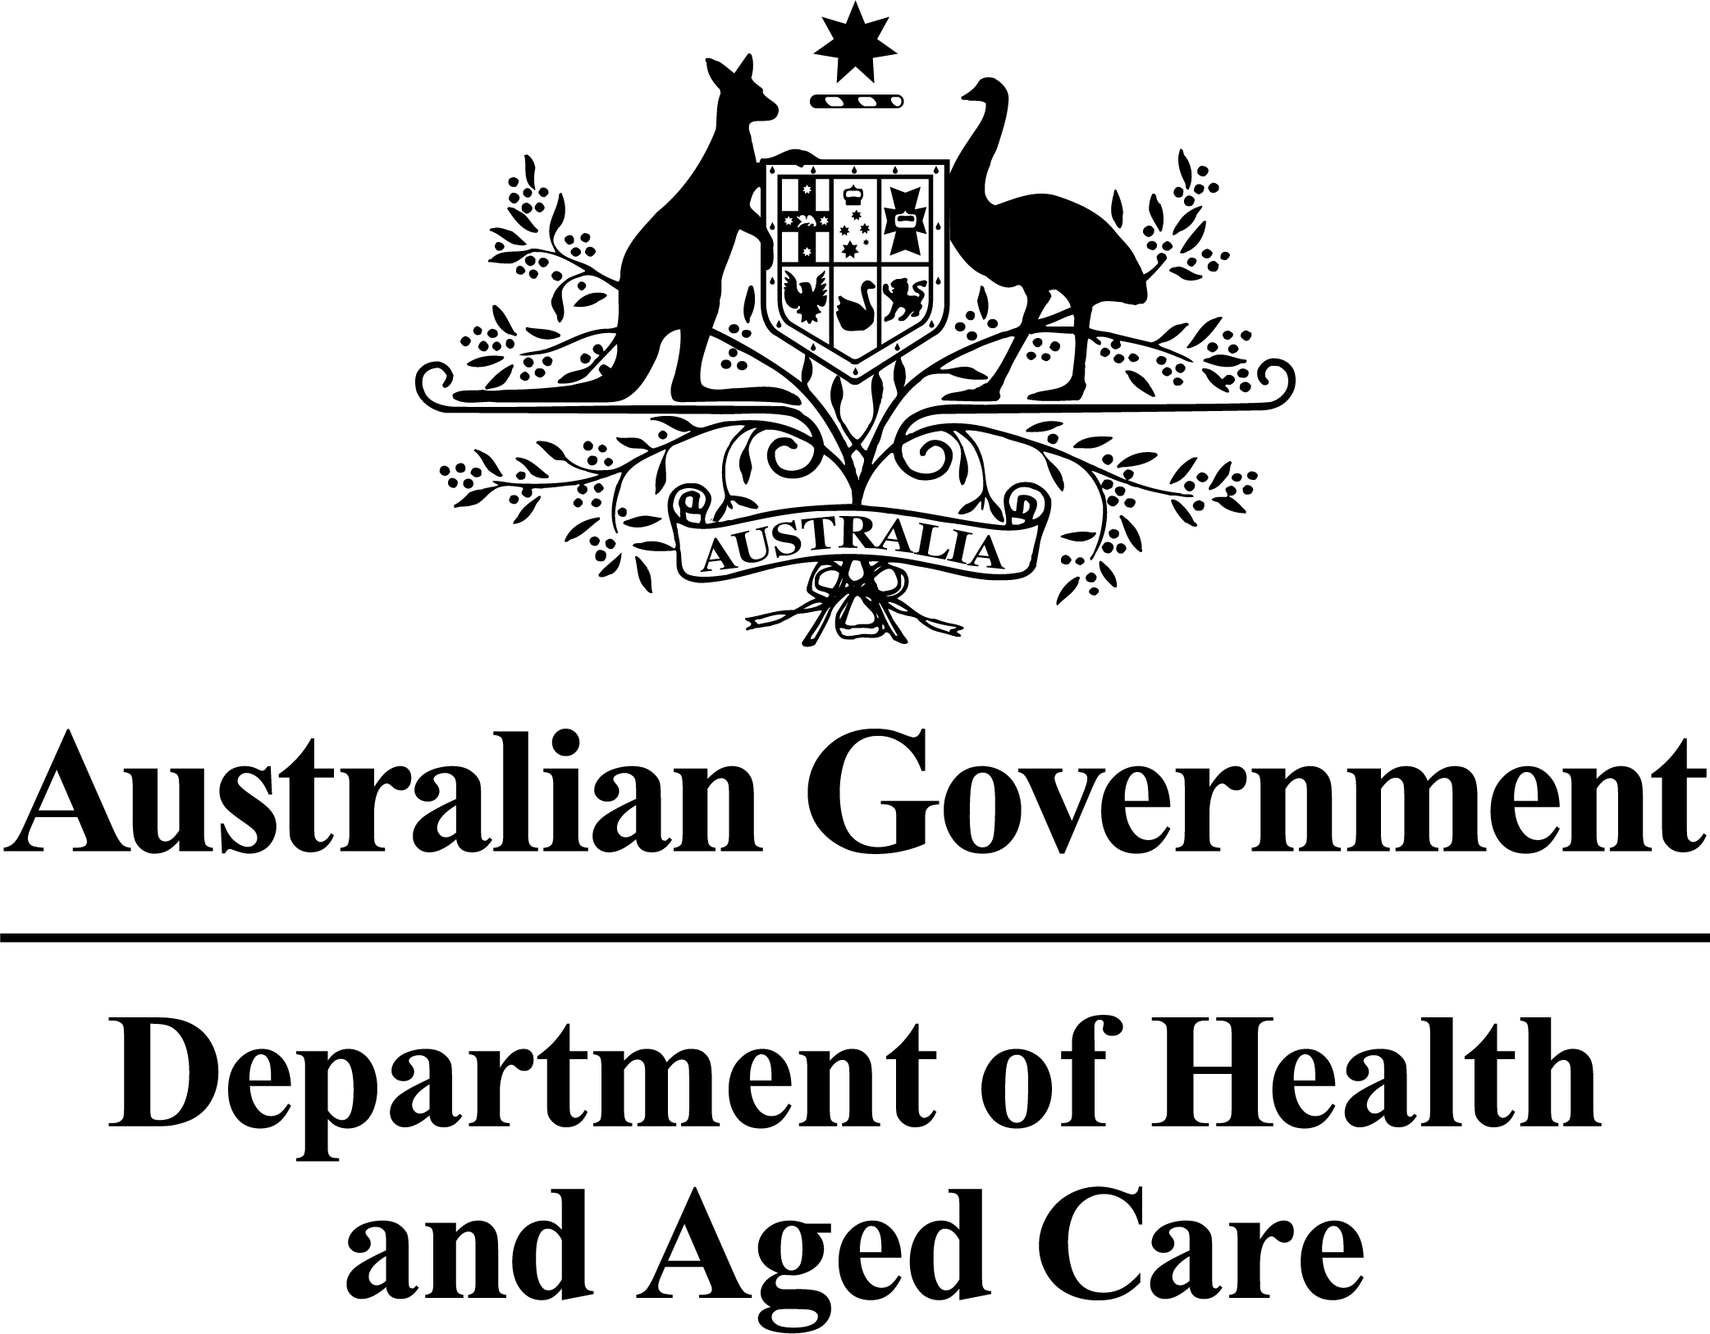
Australian Government
Department of Health and Aged Care
NATIONAL SHED DEVELOPMENT PROGRAMME
Administered by the Australian Men’s Shed Association
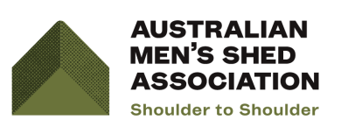
Application Form - Defibrillators
Applicants are advised to read the NSDP Programme Guidelines prior to completing this Application Form
1. The NSDP is open to all Men’s Sheds whether a member or not a member of AMSA
2. A detailed description of all eligible items/services is available within Round 29 Guidelines
3. Non AMSA members will need to evidence that they are an established Men’s Shed
4. Applicants are required to answer all sections of the form

Sheds that can meet the eligibility requirement can submit an application at any time before Friday, 7 March 2025.

Part A: Applicant Details
Please note that contact details (name and telephone number) provided on this application form may be provided to your Federal Member of Parliament. Please contact the AMSA should you not wish this to happen.
Applicant Organisational Name
If an auspice body, thisapplication is on behalf of the following Men’s Shed
Organisational Head:

Position Held
Daytime Phone No | ( )
Mobile
Email
Applicant ABN/INC NO
GST Registered |  | Yes No
To check both your ABN and GST registration:https://abr.business.gov.au/
Applicant Insurance Details
Is your Men’s Shed insured with the AMSA Group Policy? | Yes No
If No, does your Men’s Shed have an existing policy with an APRA approved insurance provider? | Yes No
Please attach a copy of the Certificate of Currency

Part B: Men’s Shed Details
Men’s Shed Name:
(if different to organisational name in Part A)
Physical Address of Men’s Shed | Street (and number):  Suburb:  State/Territory: Postcode:
Is your Men’s Shed Registered with the AMSA?  If No (a Non-Member), please provide evidence to allow your Shed’s status to be confirmed, for example Shed constitution, program of events, or other evidence of activities. |  |  | Yes No
If Yes, please provide your AMSA Membership Number AMSA
Men’s Shed Contact Person Details

Name
Position
Phone | ( )
Mobile
Email
Is this Application for an existing, or developing Men’s Shed (less than 2 years old?)? | Developing Existing
Do you own the premises from which the Men’s Shed operates? | Yes No
If no, written permission from the owner/s to install the defibrillator must be attached to your application

Part C: Eligibility and Budgets
Please complete all applicable sections
Category 5 - Defibrillators [up to $2,250]
- Eligibility –Defibrillators
Have you previously been funded through the NSDP or the Australian Government’s Defibrillator program for the purchase of a defibrillator? | Yes No
If Yes, what date did you receive funding? | / /
Do you currently have a working defibrillator on your premises? | Yes No
If Yes, what date was the defibrillator acquired? | / /
- Budget – Defibrillators
Item/Service Description | Cost $
Total Amount requested  Please note: the total of all Defibrillator requests must not exceed $2,250. | $

Part D: Authorisations and Declaration

This section must be signed by personnel/officer with delegation of authority such as an elected Committee member.

Declaration:
- I have read and understand the Round 29 Programme Guidelines.

- I declare that, to the best of my knowledge, all the information provided within this application is true and correct.

- I have attached all essential attachments.

- I will notify AMSA of any changes of information or circumstances that may affect this application.

- I understand this is an application and may not necessarily result in funding.

Signature on behalf of applicant:
Name ________________________________________________
Position _______________________________________________
Signature ______________________________________________
Date___ /___ /_____

Signature of Witness:
Name_________________________________________________
Signature ______________________________________________
Date___ /___ /_____

Part E: APPLICATION and DOCUMENT CHECKLIST
Important: Please ensure ALL essential documentation is attached as applicationswith missing essential documentation willbe eliminated.
Please tick boxif attached
Auspiced/sponsored Men’s Sheds | Memorandum of Understanding or Agreement between the Men’s Shed and the applicant organisation | ☐
Quotes | All items requested must be supported with one written quote.  Costings from online traders will be acceptable as quotes where theyclearly detail what is being offered and where the online trader displays a current ABN number. | ☐
Consent for installation | If applicable, information on the ownership of the premises with written consent from the relevant owner for the installation of a defibrillator | ☐
Application Form | If submitting application electronically - One (1) signed and scanned copy of completed application form with attachments included, as a single PDF document only. | ☐
Application Form | If submitting application by mail –One(1) signed copy ofcompleted application form and attachments. | ☐
Non AMSA members | If a Non-Member, please provide evidence to allow your Shed’s status to be confirmed, for example Shed constitution, program of events, or other evidence of activities | ☐
If you require any additional help or support with the application process please email amsa@mensshed.net or phone 1300 550 009 or contact your Regional Coordinator.

Lodging your Application

- Email: The signed Application and all attachments may be emailed to amsa@mensshed.net
[NOTE: Please email your signed Application Form and attachments as one single PDF document (including quotes, images etc.) only and not individual jpeg/word or PDF files. Please refer to the AMSA Step by Step Guide-if you are unable to email as one complete document, please post by regular mail.]
OR
- Post: ONE COPY of the completed and signed Application and attachments – please do not package the application documents into a bound folder or staple.

Applications must be posted to:

Australian Men’s Shed Association
Re: Australian Government National Shed Development Programme - Defibrillators
PO Box 793
The Junction NSW 2291

